Pengembangan Aplikasi Pembookingan Lapangan Badminton Berbasis Desktop Khusus Admin

**Rolly Lontaan1, Thimothy Reymar Pongantung2, Andika Pujianto3, David Pintunaung, Gilbert Palari5, Paris Rawung6**

Fakultas Ilmu Komputer, Informatika, Universitas Klabat, Jl. Arnold Mononutu, Airmadidi Bawah, Kec. Airmadidi, Kabupaten Minahasa Utara, Sulawesi Utara 95371, Indonesia

e-mail**:1**[**rolly.lontaan@unklab.ac.id**](mailto:rolly.lontaan@unklab.ac.id)[**2s22210097@student.unklab.ac.id**](mailto:2s22210097@student.unklab.ac.id) **,** [**3s22210088@student.unklab,.ac.id**](mailto:3s22210088@student.unklab,.ac.id)**,** [**4s22210250@student.unklab.ac.id**](mailto:4s22210250@student.unklab.ac.id)**,** [**5s22110229@student.unklab.ac.id**](mailto:5s22110229@student.unklab.ac.id)**,**[**6s22210169@student.unklab.ac.id**](mailto:6s22210169@student.unklab.ac.id)

***Abstract***

*Efficient management of badminton court reservations is essential to support the optimal operation of sports facilities. This study aims to develop a desktop-based badminton court booking application specifically for administrators to simplify the organization and recording of reservations. The application was developed using Visual Studio as the development platform and MySQL as the database. Key features include schedule management, rental price settings, and an integrated payment system. The software development method used is the Waterfall model, covering needs analysis, system design, implementation, and testing. Testing results indicate that the application accurately records reservation data, displays real-time schedules, and generates daily reports. This application is expected to improve the efficiency of badminton court management and minimize errors in the booking process, thus supporting quicker and more accurate decision-making by administrators*

***Keywords*** Badminton court boking, Desktop Application, Reservation management

**1. INTRODUCTION**

Managing badminton court reservations is crucial for efficient operations at sports facilities. [1]. In today's digital age, manual systems are often inefficient and prone to errors in recording and scheduling conflicts. This can increase the workload for facility managers and negatively impact all parties involved, both in terms of time and finances. [2]. Therefore, the use of desktop-based applications specifically for administrators is a relevant solution to increase accuracy and speed in reservation management [3]. Desktop-based applications also enable more structured and secure data management, reduce human error, and provide efficiency in the use of time that is much needed in facilities management [4].

Several studies have explored the development of sports facility management applications; however, many of these have not fully optimized features that enhance administrative efficiency, such as schedule management, payment recording, and automated report generation [5]. For instance, the schedule management applications in many sports facilities still rely on manual recording or use software that lacks integration with other systems [6]. This research aims to build upon previous studies by creating a desktop-based badminton court booking application specifically designed for administrators. The application will be developed using Visual Studio and MySQL [7] By utilizing MySQL as the database, the application will ensure organized and easily accessible data storage, allowing for effective long-term management of substantial transaction data [8].

This application is designed to meet the needs of badminton facilities in managing court rental schedules, setting prices, and effectively storing transaction history. With a centralized and integrated system, it is expected to minimize errors in reservation management, support fast and accurate booking processes, and provide convenience for administrators in decision-making [9]. One of the main advantages of this system is its ability to provide automated reports that can assist administrators in managing various aspects, such as transaction history and court usage [10]. For example, automated daily reports will speed up data processing and minimize errors in record-keeping [11].

In addition, this application is designed with a simple yet functional user interface, making it easier for administrators to manage schedules and transactions [12]. With a centralized system, administrators can manage data more quickly, such as updating field status or confirming payments, without relying on a manual system that can slow down the process [13]. Previous research has also shown that centralized systems like this can improve operational efficiency and provide significant long-term benefits for sports facility management [14]. The use of a desktop-based interface also reduces the potential for disruptions or errors that may occur with web-based or mobile applications in unstable network conditions [15].

By adopting a desktop-based application solution, this system aims to reduce dependence on manual processes that often consume a lot of time and energy [16] This change allows administrators to focus more on strategic decision-making, such as improving services and developing other facilities [17]. All these elements contribute to making this badminton court booking application a very useful tool for managing sports facilities, ensuring that the court booking process runs more smoothly and efficiently [18].

**2. RESEARCH METHODS**

This section outlines the method employed in developing a desktop-based badminton court booking application. The research follows a sequential approach based on the waterfall model, which is recognized for its systematic structure in organizing software development stages. This model was selected because it offers a clear and organized sequence of steps, ranging from requirements analysis to system testing, thereby minimizing the risk of unstructured development. [19] [20].

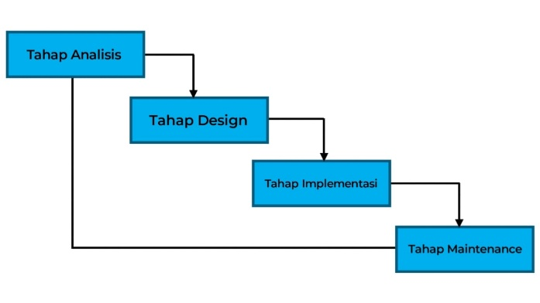

*Gambar 1. Waterfall model*

The waterfall model comprises several key phases: requirements analysis, system design, implementation, testing, and maintenance. In this research, each phase is approached with a focus on user needs and relevant technologies to ensure that the application meets its primary objectives.

## 2.1 Tahapan Pengembangan Sistem

## 2.1.1 Analisis Kebutuhan

The needs analysis stage involves collecting data through direct observation of the manual reservation process at sports facilities and conducting interviews with managers to understand operational needs and existing constraints. The main goal is to identify functional requirements, such as recording reservations, managing field schedules, setting prices, and generating automatic reports [21]. Non-functional requirements are also considered, including application performance, data security, and ease of use by administrators. This analysis technique follows best practice guidelines in software engineering to ensure relevant and implementable results[22].

## 2.1.2 Perancangan Arsitektur Sistem

System design starts with the development of a desktop architecture using Visual Studio, integrated with a MySQL database. This process involves creating a use case diagram to illustrate user interactions with the application, along with a data flow diagram (DFD) to ensure that data flows align with operational requirements. [23] [24]. The interface design aims to be intuitive and enhance administrator efficiency. The database schema is structured with normalization up to the third normal form (3NF) to minimize redundancy and maintain data consistency. [25].

## 2.1.3 Implementasi

The application was developed using the C# programming language in Visual Studio, which is well-suited for creating desktop applications featuring an interactive graphical interface. MySQL is employed for data management, encompassing tables for user data, schedules, transactions, and reports. To enhance code modularity, object-oriented programming (OOP) techniques are utilized [26]. Key features such as input validation, schedule search capabilities, and time-based notifications have been implemented to optimize the user experience. Furthermore, the application undergoes rigorous testing in a controlled environment to ensure compatibility with the Windows operating system[27].

## 2.1.4 Pengujian Sistem

System testing is conducted using the Black Box Testing method, which emphasizes evaluating the application's functionality based solely on inputs and outputs, without delving into the internal code. This testing encompasses validating input data, managing schedules, generating reports, and ensuring data security [28]. The evaluation of test results aims to identify potential implementation errors. Should any bugs or anomalies be detected, debugging is executed, followed by a retest of the system to confirm its stability and reliability.

**3. RESULT AND DISCUSSION**

*3.1 Use Case Diagram*

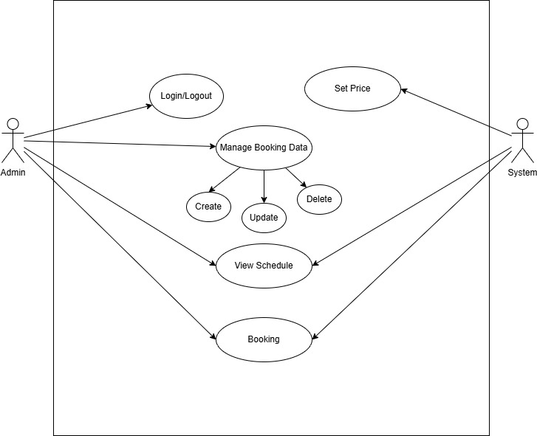

Figure 2. Use Case Diagram

Figure 2 depicts a use case diagram for the application, visually illustrating the main activities and the relationships between actors and application features. The explanations for each scenario have been crafted to align with the operational needs identified during the requirements analysis phase.

To enhance clarity, each scenario includes detailed steps that outline the initial conditions (preconditions), the conditions that follow execution (postconditions), and the actions taken by both the actor (admin) and the system. These steps serve as a reference to ensure that each application feature is implemented as intended.

*3.2 Use Case Description*

1. Use Case Name: Login/Logout

- Actor: Admin

- Precondition: The admin is on the application login page.

- Postcondition: The admin successfully logs into or out of the system.

- Steps Performed:

1. The admin enters their username and password on the login page.

2. The system verifies the provided credentials.

3. If successful, the admin is directed to the application's main page.

4. The admin can select the logout option to exit the application.

2. Use Case Name: Set Price

- Actor: System

- Precondition: The system has access to the pricing configuration database.

- Postcondition: The rental price field is updated according to the latest configuration.

- Steps Performed:

1. The admin sets or updates the hourly field rental price in the pricing settings menu.

2. The system saves the updated price data to the database.

3. The new price is applied to all subsequent bookings.

3. Use Case Name: Manage Booking Data

- Actor: Admin

- Precondition: The admin is on the main page and has access to the booking data management feature.

- Postcondition: New booking data is added, updated, or deleted from the system.

- Steps Performed:

- Create:

1. The admin enters new renter data, such as name, phone number, and other details.

2. The system saves this data in the database.

- Update:

1. The admin selects the renter data to be updated.

2. The admin modifies the necessary information and saves it.

3. The system updates the data in the database.

- Delete:

1. The admin selects the renter data to be deleted.

2. The system deletes the data from the database.

4. Use Case Name: View Schedule

- Actor: Admin

- Precondition: The admin is on the main page of the application.

- Postcondition: The admin views the registered field booking schedule.

- Steps Performed:

1. The admin selects the "View Schedule" feature.

2. The system displays the field booking schedule, including the start and end times of each booking.

5. Use Case Name: Booking History

- Actor: Admin

- Precondition: The admin is on the main page of the application.

- Postcondition: The admin views the history of previous field bookings.

- Steps Performed:

1. The admin selects the "Booking History" feature.

2. The system displays booking data, including details of the time, renter, and booking status.

*3.3 Interface Implementation*

1. **Login Page**

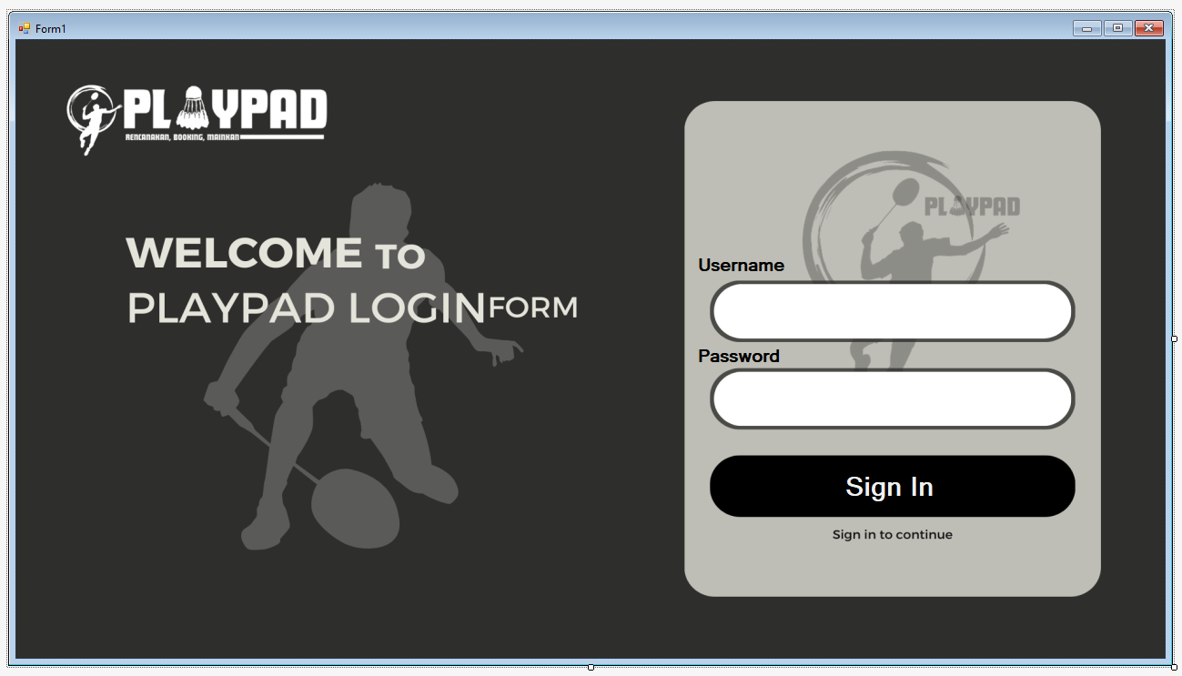

Figure 3. Login Page

On the login page shown in Figure 3, the administrator can access their account by entering the existing username and password.

1. **Home Page**

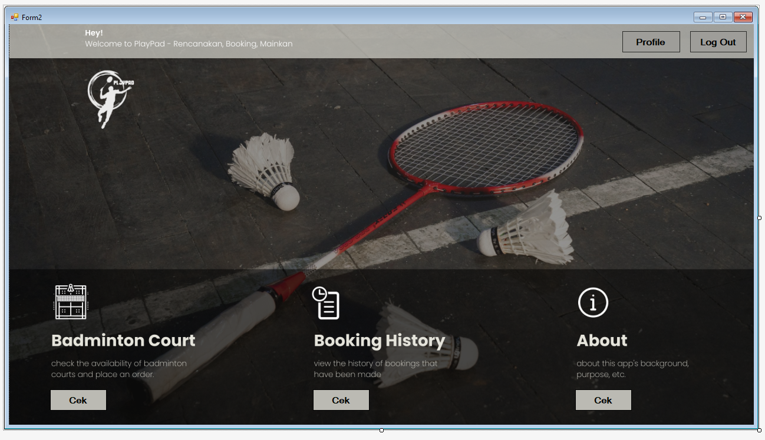

Figure 4. Home Page

In Figure 4, the Home Page allows the administrator to check the Badminton Court, view Booking History, and learn About the application we have created.

1. **Court Page**

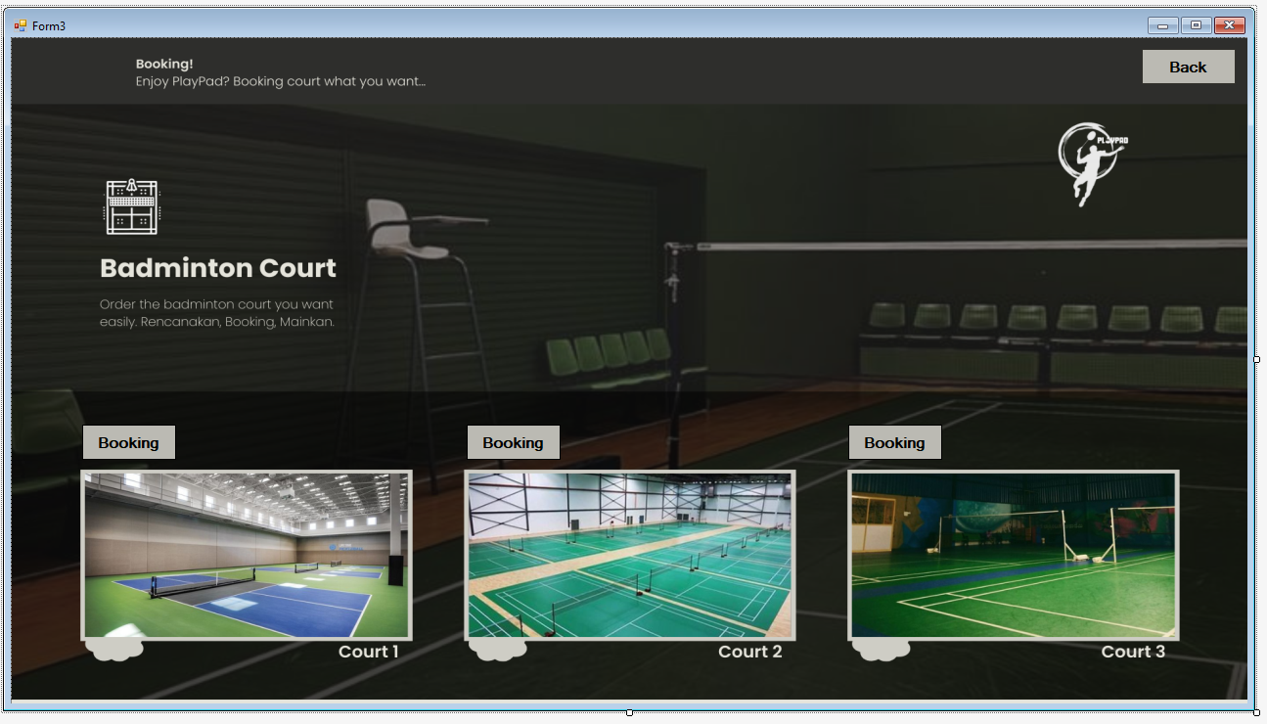

Figure 5. Court Page

In Figure 5, the Court Page allows the administrator to select which court the customer will book. There are three available options: Court 1, Court 2, and Court 3.

1. **Booking Page**

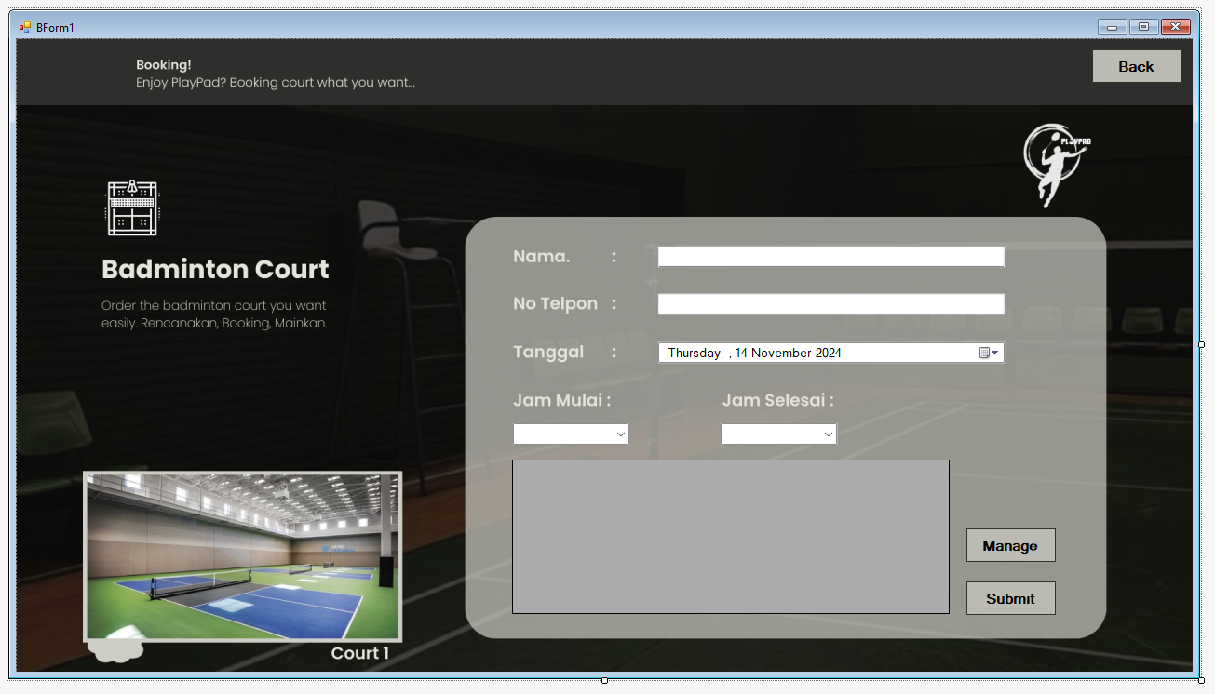

Figure 6. Booking Page

In Figure 6, titled the Booking Page, the administrator is required to enter specific information related to the booking. This includes the name, telephone number, date, start time, and end time. Once all the necessary data has been filled in, the administrator can click the submit button to display the information in the Data Grid View on this page.

1. **Manage Page**

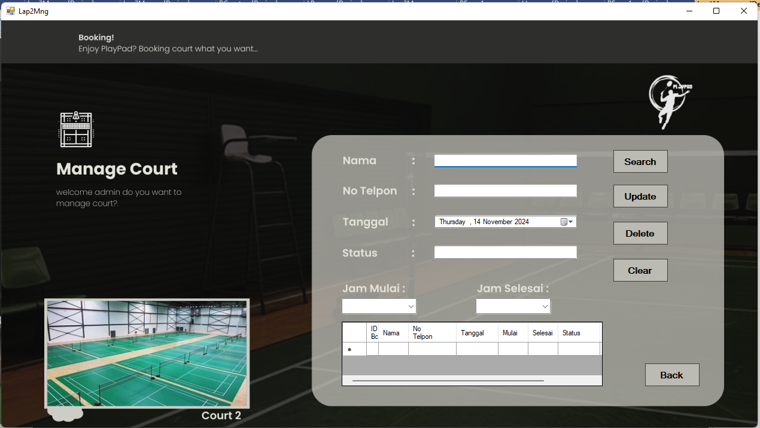

Figure 7. Manage Page

In Figure 7, the Manage Page allows the administrator to search for, update, and delete information about customers who have made previous bookings. The purpose of the "Clear" button is to erase the data in the text box, enabling the administrator to search for other customers who may need to update their information.

1. **Profile Page**

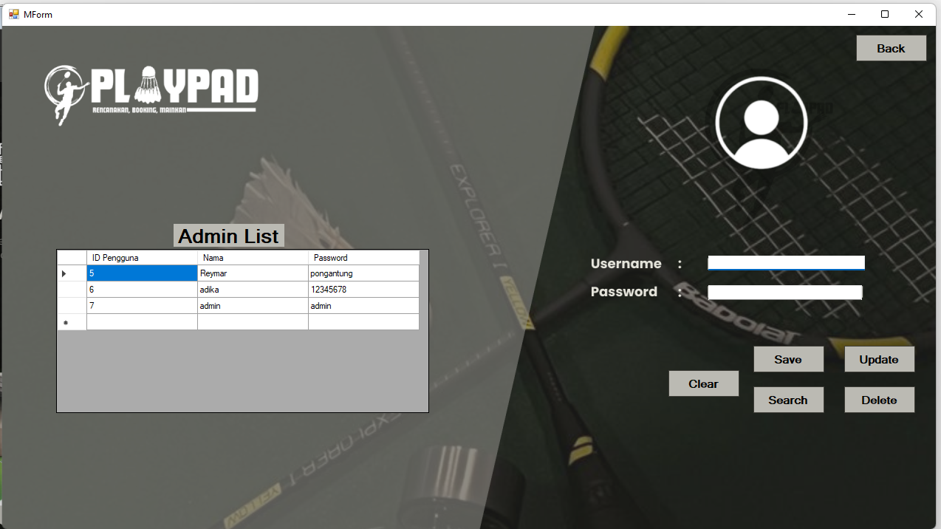

Figure 8. Profile Page

In Figure 8, the Profile Page displays a list of administrators registered with the application we have created. Here, administrators can also add, update, search, and delete data for those who have registered.

1. **About Page**

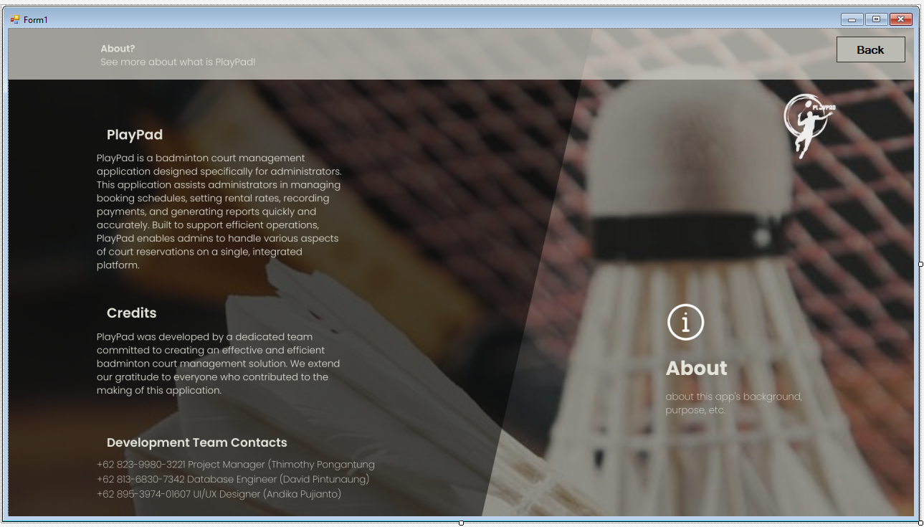

Figure 9. About Page

In the About Page, shown in Figure 9, the administrator can view information about the application we created. Additionally, they can see our contact details, including our WhatsApp number and our roles during the application's development.

1. **History Page**

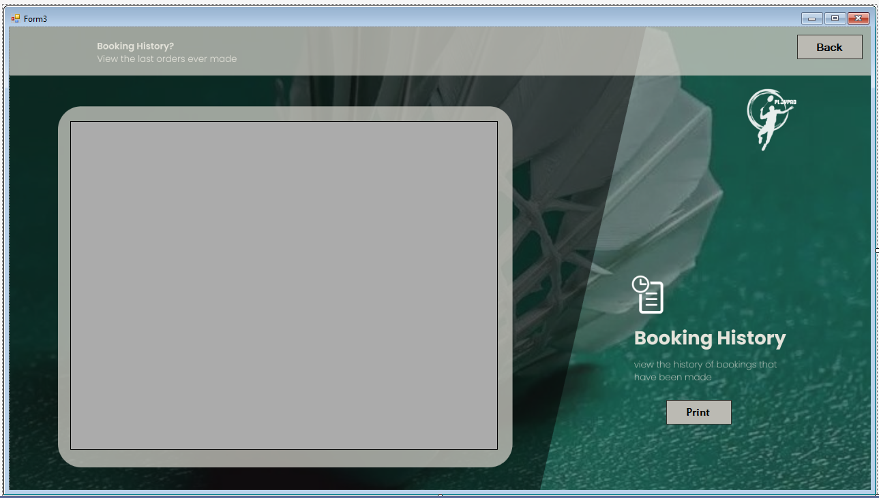

Figure 10. History Page

Figure 10 displays the History Page, where the administrator can view a list of individuals who have previously booked fields. Data from fields 1, 2, and 3 is compiled and presented on this page. Additionally, the administrator has the option to click the print button for better visibility of the data and to proceed to the Crystal Report.

1. **Crystal Report**

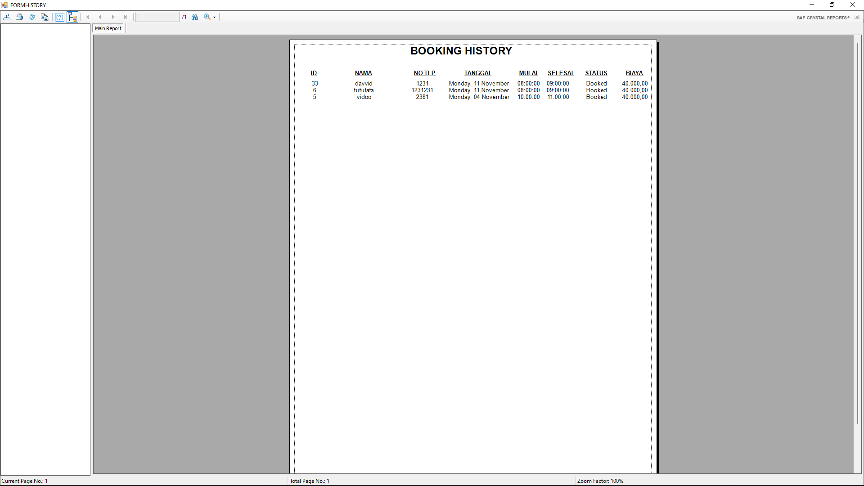

Gambar 11. Crystal Report

In Figure 11, the administrator can view the data from the booking history page by pressing the print button. Additionally, the administrator has the option to save or print the data that is already available in the Crystal Report.

**4. CONCLUSION**

This desktop-based badminton court booking application was successfully developed using the Visual Studio platform and MySQL for the database. According to test results, the application enables administrators to manage field reservations efficiently and accurately. Key features such as scheduling, transaction recording, and daily report generation have demonstrated effectiveness in enhancing data management accuracy compared to manual methods.

The use of the Waterfall development model yielded optimal results, ensuring that each stage of development was conducted in a structured and systematic manner. With a centralized management system, the application aims to minimize errors in the reservation process and expedite decision-making by administrators.

This application is anticipated to be an effective solution for managing badminton facilities, facilitating smoother operational activities, and providing a better user experience for administrators. Future development may consider integrating online payment systems to expand the application's functionality.

# 5. ACKNOWLEDGEMENTS

We express our heartfelt gratitude to God Almighty for the wisdom and health bestowed upon us throughout the process of creating this application, which has now been completed to our satisfaction. With His guidance, the author was able to overcome every challenge encountered during the development of this application.

We would also like to extend our thanks to the Faculty of Computer Science at Klabat University for the opportunities and support provided. A special acknowledgment goes to our supervisor, whose patient guidance, motivation, and valuable insights were instrumental in ensuring the successful completion of this application. We hope that their dedication and mentorship will continue to inspire future generations.

Additionally, we are thankful to our family and friends for their unwavering moral support and encouragement, which served as a vital source of strength throughout this journey. The author dedicates this work to the glory of God, family, and all those who have made positive contributions along the way.

# REFERENCES

|  |  |
| --- | --- |
| [1] | J. Smith, "Efficiency in Sports Facility Management Systems," *International Journal of Sports Managemen,* vol. 20, no. 1, pp. 23-45, 2020. |
| [2] | A. Brown, Manual Systems in Modern Sports Facilities, New York: Sports Management Press, 2019. |
| [3] | M. &. L. R. Zhang, "Development of Desktop Reservation Systems for Sports Facilities," in *International Conference on Sports Technology*, 2021. |
| [4] | J. Williams, "Benefits of Desktop Applications in Facility Management," *Technology in Facility Operations,* vol. 12, no. 4, pp. 34-45, 2018. |
| [5] | V. Kumar, Analyzing the Need for Automated Sports Facility Management, Tech Press, 2020. |
| [6] | R. Sharma, "Challenges in Managing Sports Facility Reservations," *Journal of Sports Management,* vol. 22, no. 3, pp. 150-160, 2021. |
| [7] | T. A. a. D. Martin, "Integration of Visual Studio and MySQL for Facility Management," in *Proc. International Symposium on Application Development*, 2022. |
| [8] | P. Gupta, MySQL Database Design for Large-Scale Applications, 2019, 2019. |
| [9] | L. Chen, "Benefits of Centralized Management Systems in Sports Facilities," *Journal of Sports Facility Management,* vol. 18, no. 2, pp. 123-130, 2020. |
| [10] | R. Patel, "Automated Report Generation in Sports Facility Management," *Journal of Sports Data Automation,* vol. 17, no. 5, pp. 201-210, 2019. |
| [11] | M. L. a. L. Evans, "Creating Efficient Administrative Interfaces for Desktop Applications," in *Proc. International Conference on Human-Computer Interaction*, 2021. |
| [12] | G. Thomas, "Enhancing User Interface for Facility Management," *International Journal of Computer Interface Design,* vol. 5, no. 4, pp. 220-230, 2018. |
| [13] | A. J. a. M. Peters, "Optimizing Sports Facility Management with Desktop Applications," *Journal of Sports Operations,* vol. 14, no. 6, pp. 312-320, 2020. |
| [14] | H. Allen, "Effectiveness of Centralized Systems in Sports Management," in *Proc. International Conference on Sports Technology*, 2021. |
| [15] | E. Clark, "Web-Based vs Desktop Applications for Sports Facility Management," *Journal of Application Development in Sports,* vol. 9, no. 2, pp. 115-124, 2022. |
| [16] | K. Lee, "Reducing Dependency on Manual Processes in Facility Management," *Journal of Technology and Management,* vol. 10, no. 3, pp. 65-70, 2019. |
| [17] | S. Patel, "Improved Decision Making in Facility Management," *International Journal of Facility Management,* vol. 21, no. 2, pp. 55-65, 2020. |
| [18] | T. Reed, "Future of Sports Facility Management with Desktop Applications," *Sports Technology and Management,* vol. 8, no. 1, pp. 103-110, 2021. |
| [19] | R. S. P. a. B. R. Maxim, Software Engineering: A Practitioner's Approach, New York, USA: McGraw-Hill Education, 2014. |
| [20] | I. Sommerville, Software Engineering, 10th, Boston, MA, USA: Pearson, 2015. |
| [21] | B. H. W. a. D. T. A. Dennis, Systems Analysis and Design: An Object-Oriented Approach with UML ,6th, Hoboken, NJ, USA: Wiley, 2020. |
| [22] | E. Yourdon, Modern Structured Analysis. Englewood Cliffs, NJ, USA: Yourdon Press, 1989. |
| [23] | P. C. R. K. L. Bass, Software Architecture in Practice, 3rd, Boston, MA, USA: Addison-Wesley, 2013. |
| [24] | J. A. a. B. Albahari, C# 10.0 in a Nutshell: The Definitive Reference., Sebastopol, CA, USA: O'Reilly Media, 2022. |
| [25] | H. F. K. a. S. S. A. Silberschatz, Database System Concepts, New York, NY, USA: McGraw-Hill Education, 2019. |
| [26] | B. Beizer, Black-Box Testing: Techniques for Functional Testing of Software and Systems, Hoboken, NJ, USA: Wiley, 1995. |
| [27] | MySQL Documentation Team, "MySQL Reference Manual," 15 11 2024. [Online]. Available: https://dev.mysql.com/doc/refman/8.0/en/. [Accessed 17 11 2024]. |
| [28] | J. Bentley, "Programming Pearls: Writing Correct Programs," *Communications of the ACM,* vol. 27, no. 9, p. 865–871, 1984. |